

CPEN 207: INTRO TO SOFTWARE ENGINEERING

REPORT ON SOFTWARE FOR COMPUTER ENGINEERING

ABSTRACT

This is a report describing our tasks to develop a relational database for a software the Computer Engineering Department intends to develop. The functionalities of the software include;

* Student Personal information
* Student Fees Payments
* Course Enrollment
* Lectures to Course Assignment
* Lectures to TA assignment

In addition to developing the relational database, a Flutter application was developed to with interfaces for login, register and a dashboard.

INTRODUCTION

It is important to know the basics of what was done in this project and so we seek to explain a bit what a relational database is, how it works and what flutter is also about.

**What is a relational database?**

A relational database is a collection of information that organizes data points with defined relationships for easy access. In the relational database model, the data structures -- including data tables, indexes and views -- remain separate from the physical storage structures, enabling database administrators to edit the physical data storage without affecting the logical data structure.

In the enterprise, relational databases are used to organize data and identify relationships between key data points. They make it easy to sort and find information, which helps organizations make business decisions more efficiently and minimize costs. They work well with structured data.

**How does a relational database work?**

The data tables used in a relational database store information about related objects. Each row holds a record with a unique identifier -- known as a key -- and each column contains the attributes of the data. Each record assigns a value to each feature, making relationships between data points easy to identify.

The standard user and application program interface (API) of a relational database is the Structured Query Language. SQL code statements are used both for interactive queries for information from a relational database and for gathering data for reports. Defined data integrity rules must be followed to ensure the relational database is accurate and accessible.

**What is the structure of a relational database model?**

E. F. Codd, then a young programmer at IBM, invented the relational database in 1970. In his paper, "A Relational Model of Data for Large Shared Data Banks," Codd proposed shifting from storing data in hierarchical or navigational structures to organizing data in tables containing rows and columns.

Each table, sometimes called a relation, in a relational database contains one or more data categories in columns or attributes. Each row, also called a record or tuple, contains a unique instance of data -- or key -- for the categories defined by the columns. Each table has a unique primary key that identifies the information in a table. The relationship between tables can be set via the use of foreign keys -- a field in a table that links to the primary key of another table.

**Flutter**

With respect to Flutter, in recent years, it has been difficult to develop applications for both iOS and Android within less time. To overcome this, Google introduced a new framework called Flutter. It is a new reactive framework and platform for building high-performance and beautiful mobile apps. It is used extensively at Google to build business-critical apps, and by third-party developers to build popular apps. It is also used as a SDK which provides the support to build beautiful mobile apps in record time. Flutter is highly customizable, which allows it to build apps that are brand-centric, or with the look and feel of native Android and iOS apps from a single code base.

PROCEDURE

These were the procedures followed in developing the relational database using PostgreSQL;

1. Creating a new database: The basic syntax for creating a database is:  
   CREATE DATABASE db_name;
2. Creating a Schema: To create a schema, use the CREATE SCHEMA command. Give the schema a name of your choice. For example: CREATE SCHEMA myschema;
3. Creating tables need to implement the the functionalities aforementioned : A simplified basic syntax for creating tables is:

CREATE TABLE table_name (

column_name TYPE [column_constraint],

[table_constraint,]  
);

the rest of the activities performed included;

1. Creating Insert scripts that populate all the tables with sample data
2. Create Insert scripts that populate all the tables with sample data
3. Create a database function that will calculate the outstanding fees for each student in your database and return the output in json array.
4. Use your class as the data sample

With regards to developing a Flutter application with the Login, Register and Dashboard interfaces, the following procedures were followed;

Step 1: Installation of Android Studio

Step 2: Installation of the Flutter and Dart Plugins

Step 3: Creation of the Flutter Project

Step 4: Run the Build: Flutter Doctor: To ensure that your app set up the environment is correctly working, it is worth to open the terminal (Alt+F12 in Android Studio) and involve the Flutter Doctor command.

Step 5: Start Coding the Flutter App: In the creation of this project, the taskdata and API provided were used. Also, knowledge of designing interfaces were applied.

RESULTS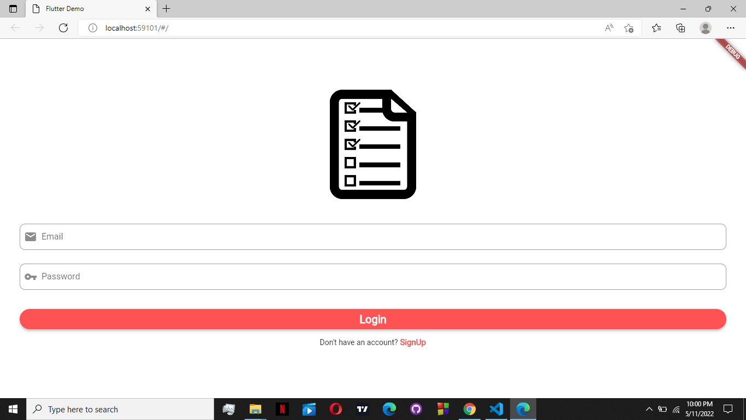

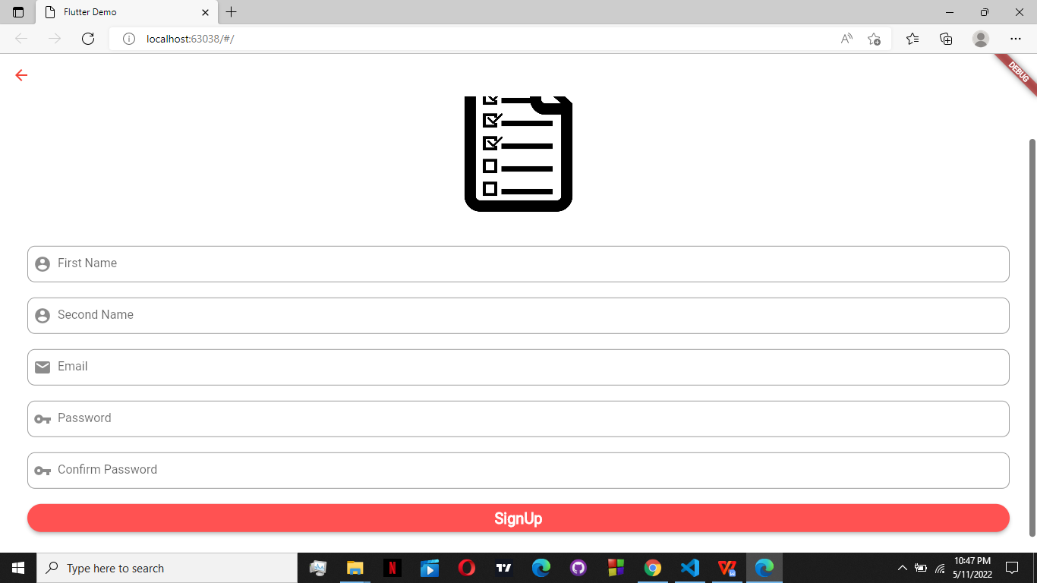

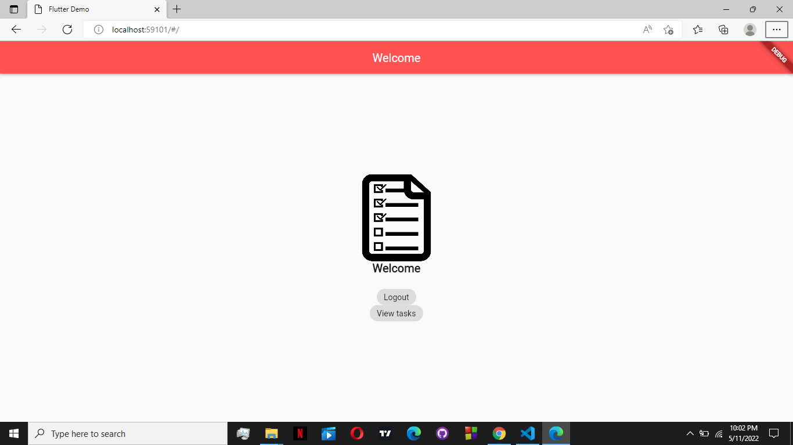

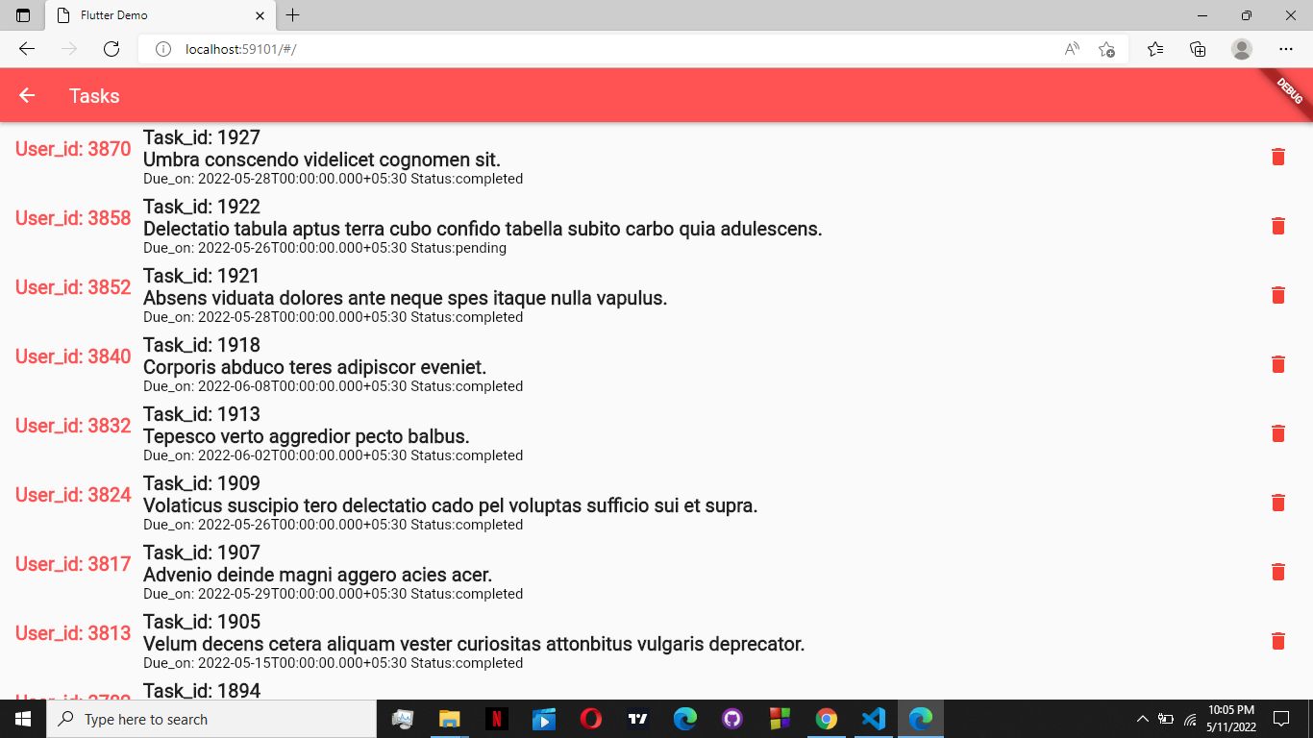

Group Members

1. YAW AFRIYIE COLE
2. TARIQ NASSER DEEN
3. BAAH NANA KWADWO ASARE
4. DANIEL OHENE-AGYEKUM

References:

<https://www.techtarget.com/searchdatamanagement/definition/relational-database>

<https://levelup.gitconnected.com/create-your-app-with-flutter-in-5-days-412ee41de22a>